Jubilee Jottings
A newsletter of the Jubilee Golf Club March 2021

Sponsors: are the key to our club’s success, look around at their signs as you play, and support them. When you do use one of our sponsors remember to let them know that you are a Jubilee Golf Club member.

MiClub suggestion: Add your email address to your profile: then if you ever forget your password you can be sent a link to create a new password.

Reciprocal Rights Jubilee Golf Club offers a 50% reduction in Green Fees for
members from Reciprocal Rights Clubs
      - Airport GC
- Barham Golf and Country Club
- Benalla GC
- Bridport GC, Tasmania
- Bright GC
- Buninyong GC
- Casterton GC
- Chalambar GC
- Churchill Waverley Golf and Bowls Club
- Cohuna GC
- Hilltop GC
- Howlong GC
- Kilmore Golf Club
- Korumburra GC
- Lakes Entrance GC
- Mansfield GC
- Murray Downs Golf and Country Club
- Myrtleford GC
- Nagambie Golf Club
- Club Mandalay
- Rossdale GC
- Sale GC
- Seymour GC
- Strathbogie GC
- Trafalgar Golf Club
- Traralgon Golf Club
- Tocumwal Golf and Bowls Club
- Tumut GC
1 / 4
- Wynyard GC

Welcome to

New Members
The following were approved as new members.

Full Members: Ashley McIlroy

Kylie McIlroy

Full Member <28: Zac Blackshaw:

Full Member <25: Lauchlan West

Country Member > 50km: David Richards

Junior (Student): Riley McIlroy

Hudson McIlroy
Please make our new members welcome

Greens Committee Request
Players will soon be able to see Steve spraying the kikuyu manually. Please take a wide berth around him so that you are not guilty of walking the spray onto the greens.

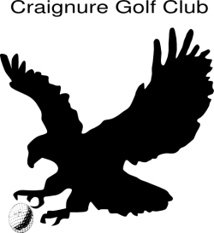

13th March Pete Evans (9th)
17th March Ben Waite (3rd)

Jubilee GC Vouchers
Vouchers won at Jubilee Golf Club in competitions can be used at the following local business houses.

Jubilee Pro Shop

Flynn Bros Mensland (Murphy St)

Wangaratta Jewellers (70 Reid St)

Wangaratta Trophies and Engravers

(64A Murphy St)
Franks Footwear (Murphy St)
Londrigan Finer Food (Rowan St)

Reality Clothing (Murphy St)

Boschs Edwards Street Butchery

(2A Edwards St)
Chicken Time (Faithful St)
Annie Mayfield (Reid St)
La Ronde (Reid St)
Lighting and Décor (Reid St)
Appin St General Store (Appin St)
The Olive Health Foods (1/61Ovens St)

Ultimate Hair Design

(797 Wangandary Road, Wangandary)
Pure Indulgence Aromatherapy
(Shop 2, 1594 Snow Road Milawa)

Vets at Benalla
Veterans have had over 30 players each Monday with a dozen players last Monday along with 21 who attended Benalla for the North East event where Alex Jones obtained nearest the pin on the 13th and Jackie O’Brien featured in the Ladies teams prize Next North East event is at Wangaratta on the 26th of April and entries close on Friday 16th April. Keep enjoying your golf.

Golf Quip
6: Tiger Woods’ age when he got his first hole in one. However. At the time he failed to beat the record for youngest hole in one which had been set by a five year old.
2 / 4

Juniors
Juniors are continuing on Thursdays with an average of 21 players attending and enjoying playing 3 holes of golf and practicing their chipping, putting and 20 minutes on the practice fairway.

Winners over the last 3 weeks are:
Eagles:
Feb 25 Ben Feldtmann
March 4 Isaac Stedman & Ben Feldtmann
March 11 Harry O’Brien & Isaac Steadman

Birdies:
Feb 25 Oli Goswell
March 4 Jack Dean
March 11 Dusty Hogarth

Jubilee Golf Club

Merchandise for sale
Ask at the bar
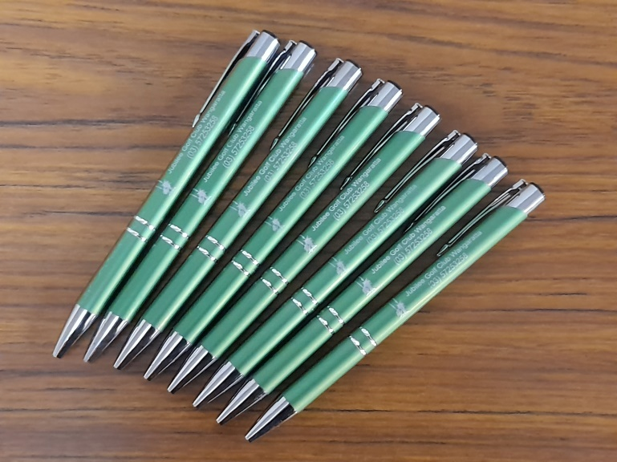
Biros: $3 each or 2 for $5.00
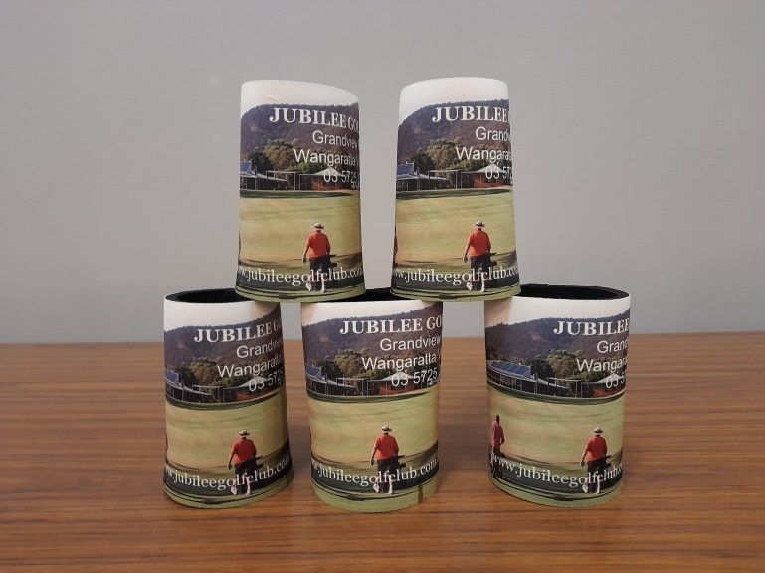
Stubby Holders: $10.00 each

Jubilee Golf Club

Annual Tournament Results

Thursday 4th March

Event: Ladies Stroke Annual Tournament
Best Handicap Score: Vicki Moorhead 71
Winners:
A Grade Scratch Di Murphy 79
B Grade Scratch Vicki Moorhead 92
C Grade Scratch Chris Boseley 100
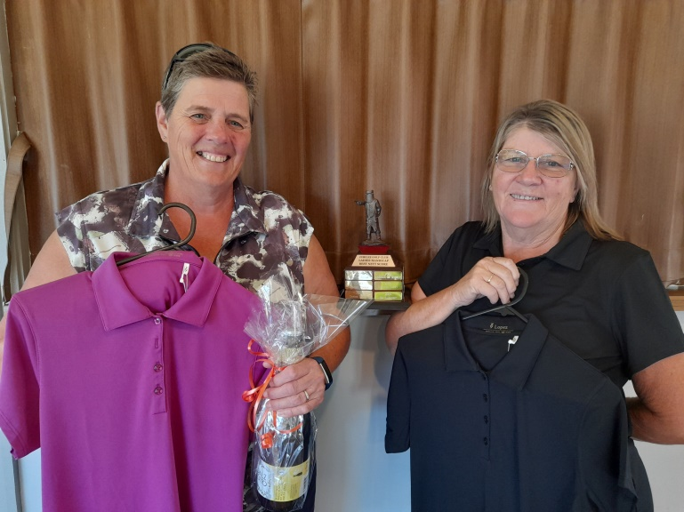

(Chris, Vicki’s Best Handicap trophy and Di
Inset: Vicki)

A Grade Handicap Jan Mills (Corowa) 77
B Grade Handicap Lynn Gent 72
C Grade Handicap Helene Gallo 74
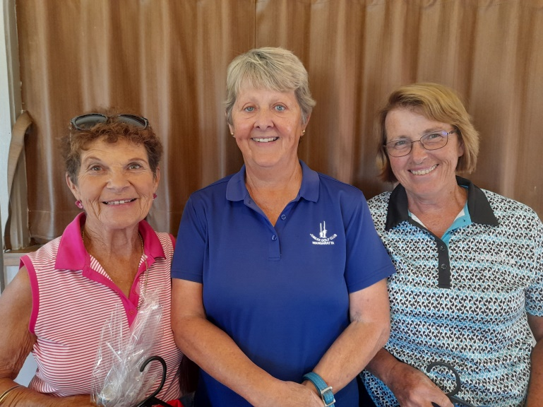
(Lynn, Helene and Jan)

Veterans 55 – 69: Vicki Moorhead 71
Veterans 70 +: Lynn Gent 72
Small Teams:
Robyn Harrison, Chris Boseley & Lynn Gent
Ball winners:
Liane Graham, Ros Kerr (Comm. Albury), Kaye Pink, Pauline Mercer, Melody Adams, Bruna McDonald, Jackie O’Brien, Frances Duffy & Judy Fogarty
3 / 4

Nearest the Pins:
4th Marie McLeish 8th Bernie McLean
13th Marie McLeish 17th Jan Mills

Friday 5th March 2021

Event: 4 BBB Stableford
Ladies
Winners: Lynn Gent & Tamlyn Godfrey 45
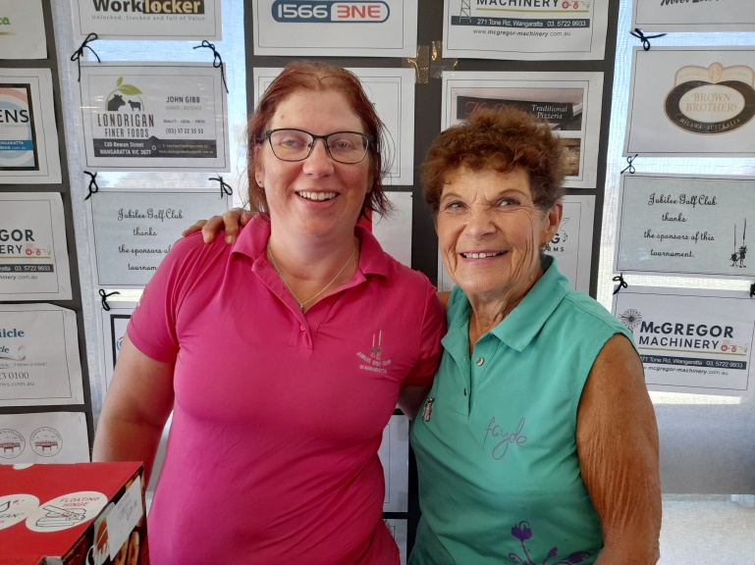
Runners Up: Pauline Mercer & Kay Pink 42 Ball Winners: Ali Comensoli & Liz Banister 41
Carolyn Haigh & Kerry Newton 40 Robyn Grealy & Helene Gallo 39
Men
Winners: Dean Cryer & Danny Fogarty 44
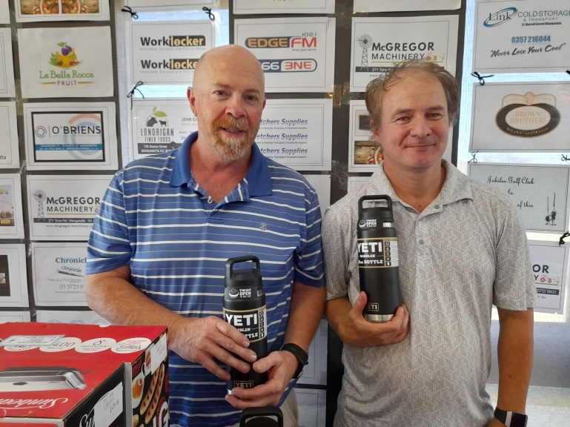
(Danny and Dean)
Runners Up: Ron Smith & Kevin Elliott 44
Ball Winners: Glenn Ryan & Rick Harnwell 41 Gary Dinsdale & Doug Ritchens 41 On a countback from Steve & Dave Richards

Saturday 6th March 2021

Event: Stroke Annual Tournament
27 Holes:
A Grade Scratch Travis Merritt 110
A Grade Nett Darren Edwards 110 ½
B Grade Scratch Paul Lawrence 129
B Grade Nett Gary Dinsdale 107
C Grade Scratch Ben Waite 134
C Grade Nett Stan Goldsworthy 115
18 Holes:
A Grade Scratch Peter Miller 77
A Grade Nett Brian Leaver 75
B Grade Scratch Andrew Skewes 84
B Grade Nett Attila Kungl 76
C Grade Scratch Kevan O’Shea 97
C Grade Nett Dave O’Connor 76
9 Holes:
A Grade Scratch Charl DeMink 36
A Grade Nett Glenn Ryan 35 ½
B Grade Scratch Rick Harnwell 42
B Grade Nett Alex Scherini 38 ½
C Grade Scratch Gary Walder 46
C Grade Nett Barry Adams 36 ½
Ball Winners:
Glenn O’Connell, Scott Gardiner, Brad Kirk, Julian Bau, Alex Gibbs, Dean Cryer, Gordon Paterson, Brian Luxford, Peter Ford and Rodney Sebire
Nearest the Pins:
4th Rodney Sebire 8th Ray Hyland
13th Charl DeMink 17th Travis Merrit

Sunday 7th March 2021

Event: VIC 4BBB Qualifier winners
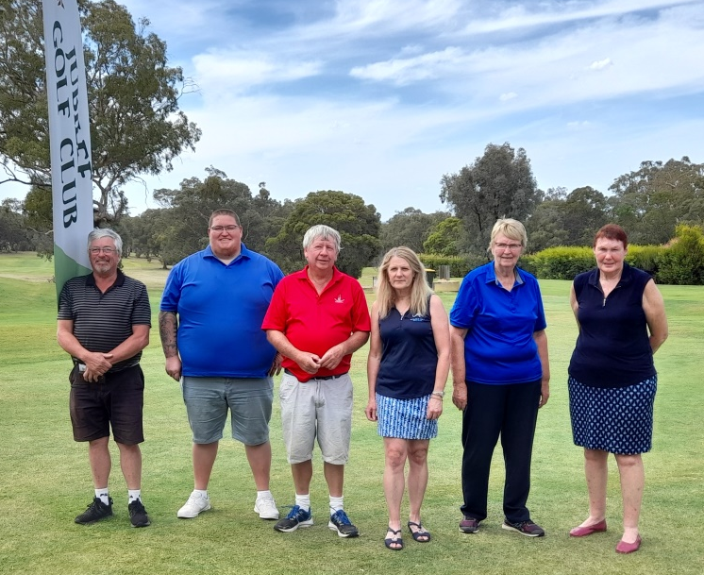
Phil Ockwell & Mitchell Bush, Steve Fisher & Ange Mitchell, Sue Barber & Lyn Vildovas

Monday 8th March 2021

Event: 3 Person Ambrose
Mixed Winners: Shannon Spinks, Sharna Chapman and Rhylee Crawford 55 1/6
Runners Up: Erika Lombard, Willem Lombard & Markus Angehrn 60 5/6
Ball Winners: ~Tamlyn O’Connor, Ryan Rea & Graeme Ulbrick 62
~Rick Harnwell, Bruce Fletcher & Kaye Pink 64 1/6
Men Winners: Steve Gulbin, Andy Senkic & Paul Cornelius 58 ½
Runners Up: Dylan Pool, Graeme Pool & Josh Sherritt 58 2/3
Ball Winners: ~Fraser Jeffrey, Mal Ellis & Rob Skase 59 1/3
~Paul McInerny, Mike Monro & Keith Moorhead 60
~Glenn O’Connell, Gordon Paterson and Glenn Ryan 60 2/3
Ladies Winners: Jackie O’Brien, Kay O’Shea & Di Murphy 65 ½
Runners Up: Frances Duffy, Jane Boland & Leeanne Carmody 69 1/6
Nearest pins:
4th Linda Stone and Ryan Rea
8th Jackie O’Brien and Damien O’Brien
13th Jackie O’Brien and Mike Monro
17th -----------------and Shannon Spinks

Next Meeting
of the board will be held on Tuesday, the 20th of April at 7.00 pm and any items you want addressed at that meeting should be sent in writing to the secretary.

4 / 4

